Linux Commands Assignment Submission

1. Creating and Renaming Files/Directories

Command:
mkdir test_dir
cd test_dir
touch example.txt
mv example.txt renamed_example.txt
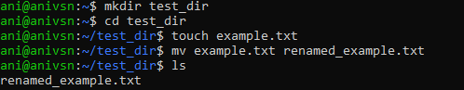

Explanation:
mkdir creates a new directory named test_dir.
cd moves into the directory.
touch creates an empty file.
mv renames the file.

--------------------------------------------

2. Viewing File Contents

Commands:
cat /etc/passwd
head -n 5 /etc/passwd
tail -n 5 /etc/passwd
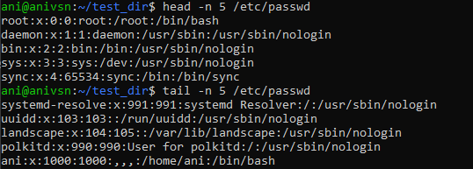

Explanation:
cat displays the entire file.
head shows the first 5 lines.tail shows the last 5 lines.

--------------------------------------------

3. Searching for Patterns

Command:
grep "root" /etc/passwd

Explanation:
grep searches for all occurrences of the word "root" in the file.

--------------------------------------------

4. Zipping and Unzipping

Commands:
zip -r test_dir.zip test_dir
unzip test_dir.zip -d unzipped_dir
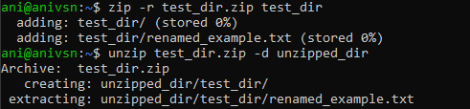

Explanation:
zip compresses the directory.
unzip extracts it into a new folder.

--------------------------------------------

5. Downloading Files

Command:
wget https://example.com/sample.txt
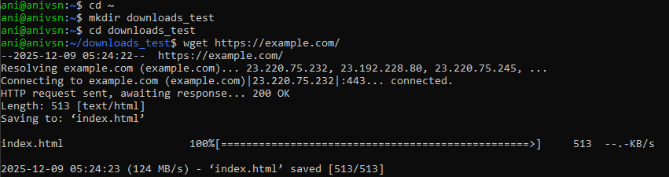

Explanation:
wget downloads files from the internet using the terminal.

--------------------------------------------

6. Changing Permissions

Commands:
touch secure.txt
chmod 444 secure.txt
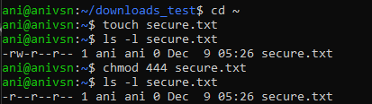

Explanation:
touch creates the file.
chmod 444 makes the file read-only for everyone.
--------------------------------------------

7. Working with Environment Variables
Command:
export MY_VAR="Hello, Linux!"

Explanation:
export sets a new environment variable in the current session.

